23 February 2007 4446 Immediate


Vehicle production – January 2007

Source: | Cars |  | Commercial Vehicles |  | Total vehicles
SMMT Ltd | Jan-07 | YTD 2007 | Jan-07 | YTD 2007 | Jan-07 | YTD 2007
Total | 124,197 | 124,197 | 19,594 | 19,594 | 143,791 | 143,791
 | 4.3% | 4.3% | 7.9% | 7.9% | 4.7% | 4.7%
Export | 94,884 | 94,884 | 11,419 | 11,419 | 106,303 | 106,303
 | 9.7% | 9.7% | -3.3% | -3.3% | 8.2% | 8.2%
% of total | 76.4% | 76.4% | 58.3% | 58.3% | 73.9% | 73.9%
Home | 29,313 | 29,313 | 8,175 | 8,175 | 37,488 | 37,488
 | -10.2% | -10.2% | 28.6% | 28.6% | -3.9% | -3.9%
% of total | 23.6% | 23.6% | 41.7% | 41.7% | 26.1% | 26.1%

Car production

'New car production in the UK rose by 4.3 per cent in January – the first increase since May 2006', said Christopher Macgowan, SMMT chief executive. 'We are starting to see a degree of stability develop in production volumes, following major restructuring and new model introductions last year. Growth came from vehicles destined for export, reflecting the continued importance of the British car industry to the global market. '
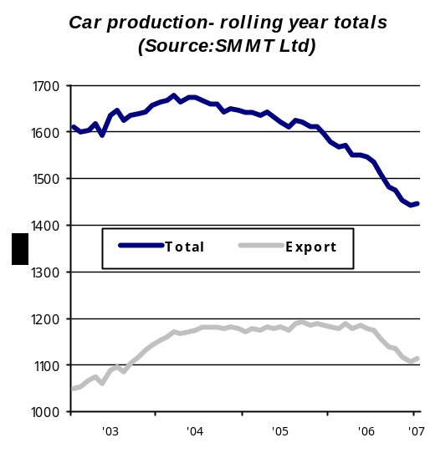

Commercial vehicle production

'Despite a fall in the production of heavy trucks, overall we saw a healthy 7.9 per cent rise in total commercial vehicle volumes in January 2007', said Christopher Macgowan, SMMT chief executive. 'Vans continue to flex their muscles in the commercial vehicle arena, with a marked increase in units destined for the home market.'
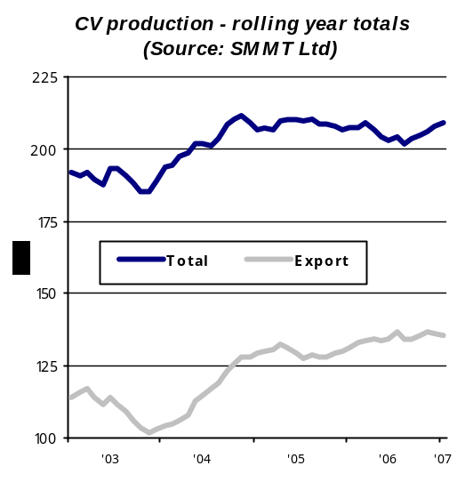`
Vehicle production – January 2007

Manufacturing Plant Profile

General Motors Manufacturing Luton  Kimpton Road  Luton  Beds  LU2 0TY  Switchboard: 01582 400 445 |  | 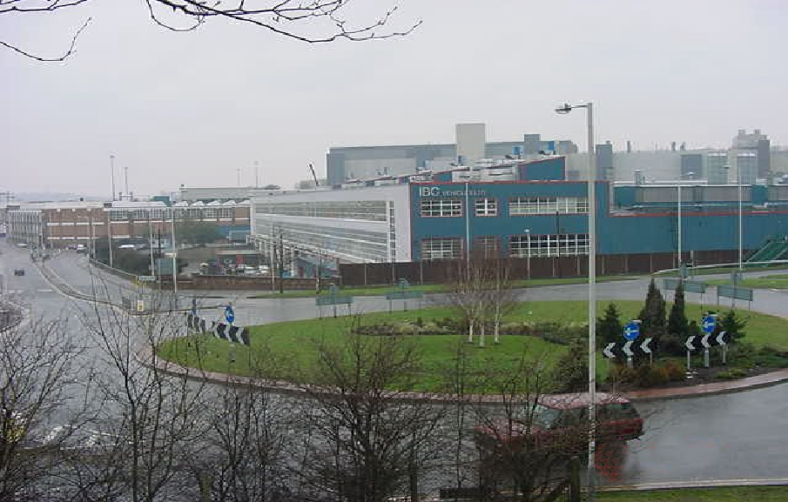
Plant Statistics:
Employees: 1747 consisting of 1543 hourly and 204 staff
Plant size: 93 acres – close to London (31.5 miles)
Accreditations held: Investors in People since 2005, ISO 9001:2000 since 2002, ISO 14001 since 2000
Models currently in production: Vauxhall/Opel Vivaro, Renault Trafic, Nissan Primastar
Production facts:
- Part of General Motors global organisation
- Three shift operation
- Capability of 18 vehicles per hour
- Capacity of 90,100 vehicles per year
- Total production of 89,065 in 2006
Plant history:
1983 New Bedford Commercial Division initiated
1986 Production of Bedford Rascal commences
1987 Isuzu and Bedford Commercial (IBC) Vehicles formed
1991 Production of Frontera commences
1996 GM and Renault sign an agreement to jointly produce a medium-sized van
1998 Became a subsidiary of GM and dedicated commercial vehicle plant
2001 Production of Vauxhall/Opel Vivaro & Renault Trafic commences
Recent project investment:
1998 £60m New Frontera 145 investment
2001 £130m invested by GM for X-83 (Vivaro, Trafic Primastar platform) set-up
2002 £16m spent on relocation of Frontera production
2006 £48m in preparation for Vivaro mid-cycle enhancement
2006 Highlights:
- No Lost Work Day Cases (LWDC) – it has been 18 months or 3.1 million working hours since the last LWDC
- The UK is GM’s fourth largest national market globally and largest in Europe
- Awarded GM Chairman’s Honours award in 2006 for successful launch of Vivaro mid-cycle enhancement
- Improved recycling with 18% per vehicle less waste in 2006 going to landfill sites compared to 2005
- Overall energy usage reduced by 8 % per vehicle in 2006 compared to the previous year
- X-83 named 'Best Small Panel Van' at prestigious What Van? Magazine Van of the Year Awards
- Named 'Best Medium Van' at the Fleet World honours ceremony
- 400,000th X-83 built at the Plant in May
Press Contacts:  Joe Jacuzzi  Communications Director  joe.jacuzzi@uk.gm.com  01582 427 620   | Tom Barnard  Press Office Manager  tom.barnard@uk.gm.com  01582 427 606

